EENG 385 - Electronic Devices and Circuits

Audio Board: Amplifier Theory

Assembly Guide

**Soldering Together the Amplifier Subsystem**

You will be soldering the amplifier subsystem for the Audio board this week. The schematic is shown in Figure 1.

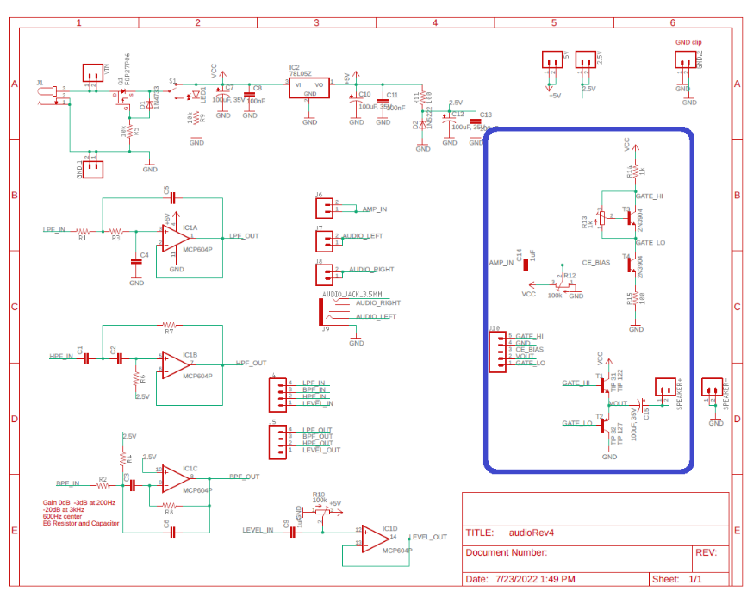

Figure : The schematic for the Audio board with the power subsystem circled in blue.

Like, your previous experiences, the parts in this schematic have a designator and a value. These designators are used to relate a part in the schematic with the layout. I converted the schematic in Figure 1 to the layout shown in Figure 2. As before, the physical position of the parts in the schematic and layout are unrelated, the schematic is an abstraction of the finished layout. The layout contains all the data used in the fabrication of the PCBs – the layout and the fabricated PCB are identical.

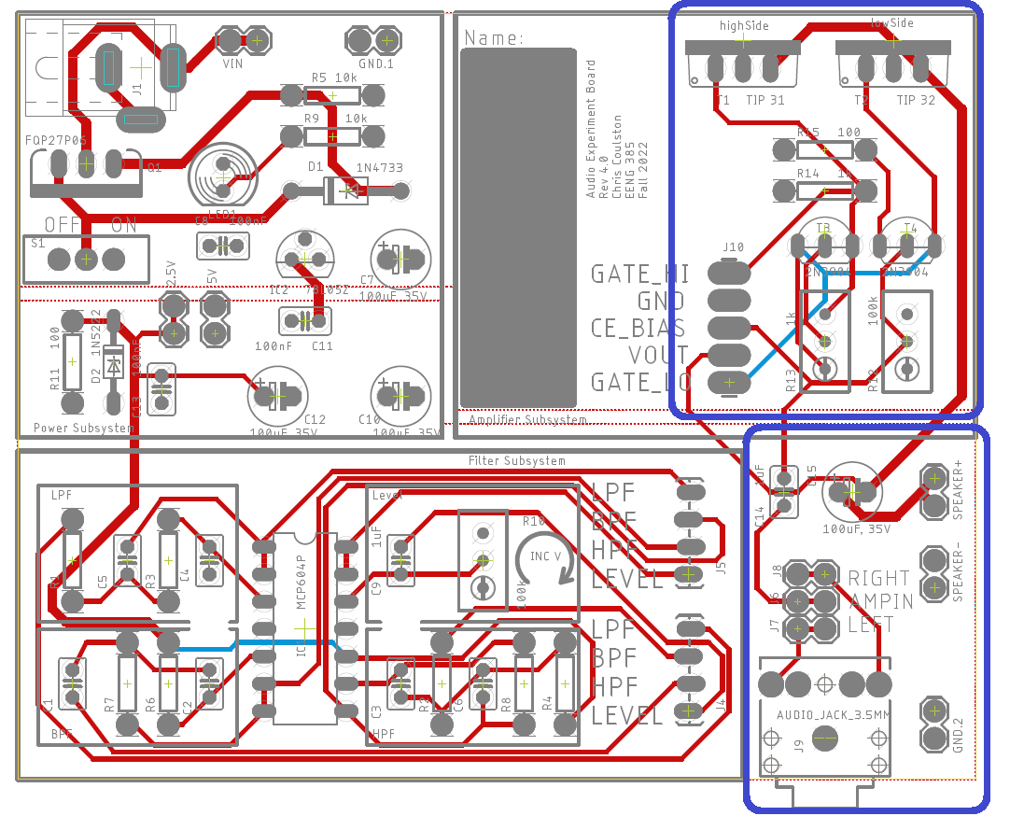

Figure : The layout of the Audio board with the power subsystem outlined in blue.

You should notice parts logically related in the schematic are physically proximal in the layout.

# Polarized Parts

Most of the parts to be soldered into the PCB can be installed in more than one way. Parts which must be installed in a correct orientation are called polarized. Polarized parts have some physical indication of their orientation, and the silk screen will have some markings to show you where this physical indicator should be aligned. Let’s walk through all the polarized parts that you will solder this week and how you will install them in the PCB.

* Red 100 µF capacitors

The 100 µF capacitors have a white stripe which indicates the negative terminal. The negative terminal should align with the white bar (opposite the “+” bar) on the PCB silk screen.

* TIP31 and TIP32 transistors

The TIP31 and TIP32 transistors are in TO-220 packages with metal tabs on the back. These metal tabs should face the edge of the board.

* 2N3904 transistor

The 2N3904 transistor is in a small TO-92 package - the package is marked “2N3904”. Make sure that its flat side matches the silk screen.

* Potentiometers

While potentiometers are not strictly polarized, you can install them either way and they will work properly, if you install them backwards, the silkscreen will not align to their function indicated on the silk screen. So, make sure to align the metal screw on the pot over the circle on the silk screen.

# General Guidance

* Reference the class soldering guide.
* You should take care with your soldering and align the resistors so their gold tolerance bands all face the bottom or right side of the board. This alignment will make it easier to compare your resistor locations with the pictures of the assembled board posted on the Canvas page.
* Solder in wire loops to the following pairs of terminals. Note I used trimmed resistor leads for this and they work great.
  + GND.2
* Solder in 2-pin headers into the following pairs of terminals
  + SPEAKER+
  + SPEAKER-
* Solder in a 2x3 header into the RIGHT, AMP_IN, LEFT headers
* Do NOT solder anything into the GATE_HI, GND, BIAS, VOUT GATE_LO headers
* Do not solder in components for the filter subsystems.

# Testing the Amplifier Subsystem

Until the pair of potentiometers are adjusted, your amplifier subsystem will not work properly. It would be best to have someone else check your component placement and orientations and check theirs. Then come to lab next week ready to learn how to adjust the potentiometers and get some sound from your amplifier.